Technical Design

Opdracht naam

Project: Opdracht naam

Version: 1.2

Autor: Stijn Schokkin

# Version management

|  |  |  |  |
| --- | --- | --- | --- |
| Date | Version | Changes | Who |
|  | 1.0 | Start technical design | SS |
|  |  |  | SS |
|  |  |  | SS |

# Index

Version management

Index

Introduction

Planning

Software architecture

Applicatie flow

User Interface Design

Database content

Application build

Agreement supervisor/project manager

# Introduction

The purpose of the technical design is to get insight in various techniques which will be used by developing the requested application. Also, there will be a clear picture with the various techniques which are connected to each other. This document is made for everyone who is concerned in this project and can find its way into the existing software.

Inleiding van andere documenten / in het engels

# Planning

|  |  |  |
| --- | --- | --- |
| **Task:** | **Who:** | **Duration:** |
| Introduction document | SS | 30 min |
| Software architecture / Application flow | SS | 30 min |
| User Interface Design | SS | 1 hour |
| Database content | SS | 2 hour |
| Application build | SS | 2 hour |

All documents will be made in Microsoft Word 2016

.

Software architecture

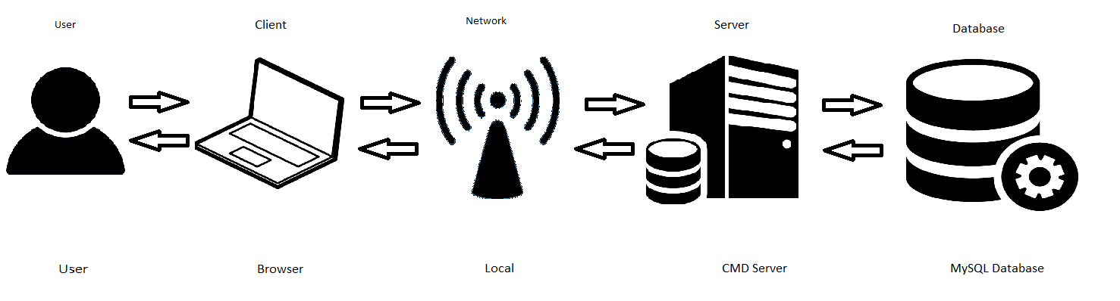

CMD (command) server and database run on the same machine. Browser is used on multiple clients.

Application Flow

User Interface Design

The following template is used for his project: [Simple Sidebar by Bootstrap](https://startbootstrap.com/template-overviews/simple-sidebar/)

Database content

Beschrijf de database, iedere table,

Class diagram:

External data:

Currently there is no external data.

.

Application structure

Folder structure:

* .git
  + Including .git files
* admin
  + Including all admin files/includes
* css
  + Including all CSS files
* inc
  + Including all .php includes
* login
  + All login files are stored here. [Login system used](https://github.com/fethica/PHP-Login)
* vendor
  + including bootstrap core CSS/JS files
  + including plugins
  + including jQuery core files

# 

# Agreement supervisor/project manager

|  |  |
| --- | --- |
| Name |  |
| Date |  |
| Autograph |  |